**Mini Edit**

**“B”**

**-File**

**-New**

**-open**

**-Save as**

**-Exit**

**- 3x3 options**

**-Copy**

**-Cut**

**-Paste**

**-User friendly**

**“A”**

**-Save**

**-Undo**

**-Select all**

**-Check for changes**

**- Save Formatting**

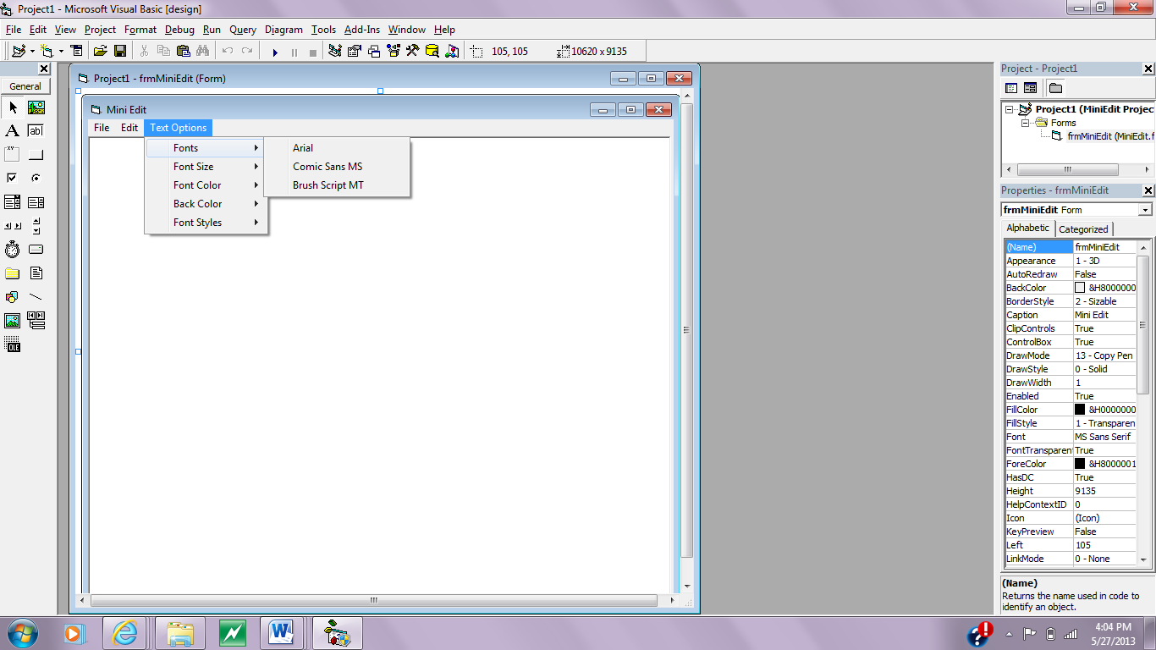**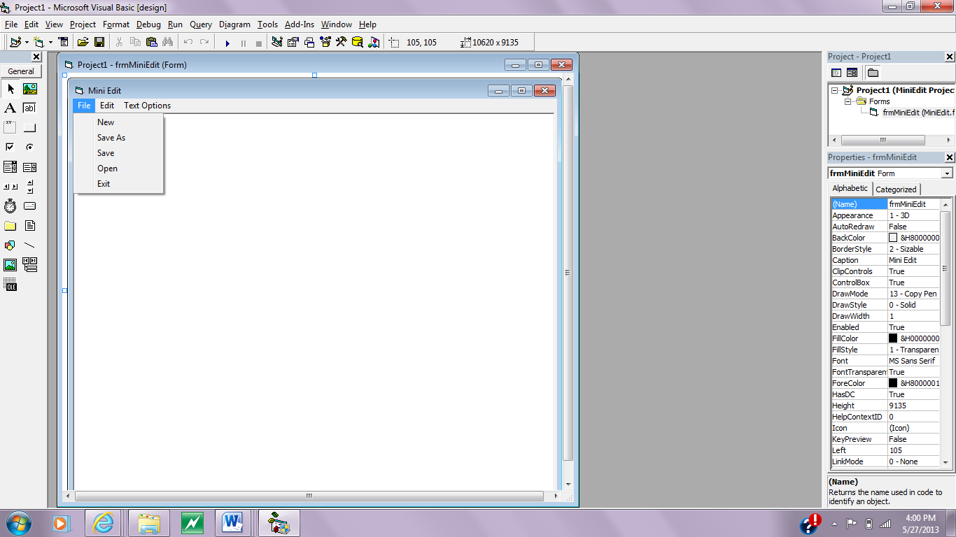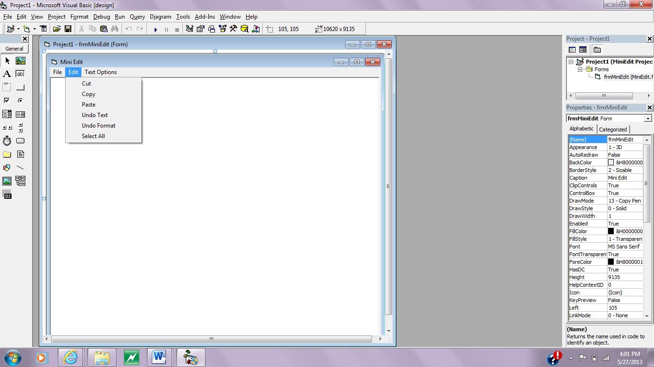Menus**:

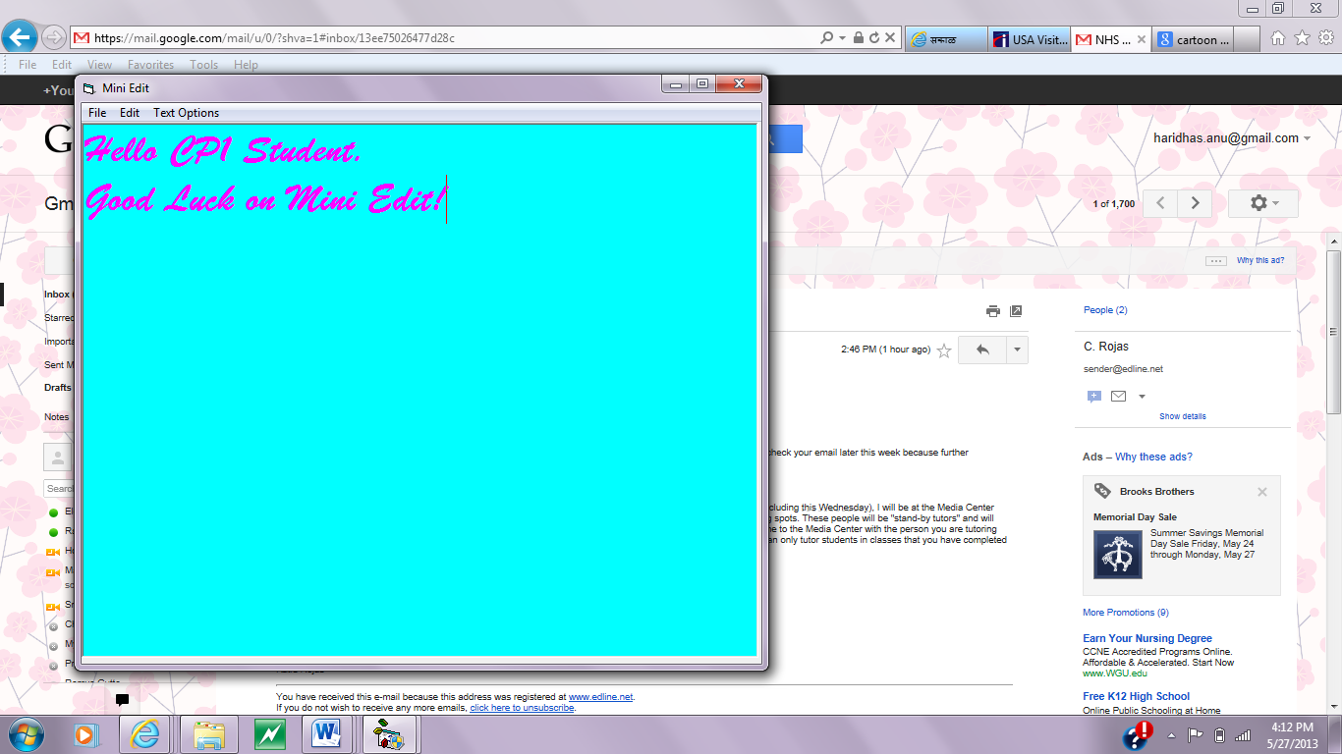**Full Form:**

